Lab - Working with Database in Python Programming
1. Create the following tables:
Table name: CLIENT_MASTER
Column Name | Data Type | Size | Attributes
CLIENTNO | Varchar | 6 | Primary Key / First letter must start with ‘C’
NAME | Varchar | 20 | Not Null
CITY | Varchar | 15
PINCODE | Number | 8
STATE | Varchar | 15
BALDUE | Number | 10,2

Table_Name: PRODUCT_MASTER
Column Name | Data Type | Size | Attributes
PRODUCTNO | Varchar | 6 | Primary Key / First letter must start with ‘P’
DESCRIPTION | Varchar | 15 | Not Null
PROFITPERCENT | Number | 4,2 | Not Null
UNITMEASURE | Varchar | 10 | Not Null
QTYONHAND | Number | 8 | Not Null
REORDERLVL | Number | 8 | Not Null
SELLPRICE | Number | 8,2 | Not Null, cannot be 0
COSTPRICE | Number | 8,2 | Not Null, cannot be 0

Table_Name: SALESMAN_MASTER
Column Name | Data Type | Size | Attributes
SALESMANNO | Varchar | 6 | Primary Key / First letter must start with ‘S’
SALESMANNAME | Varchar | 20 | Not Null
ADDRESS1 | Varchar | 30 | Not Null
ADDRESS2 | Varchar | 30
CITY | Varchar | 20
PINCODE | Number | 8
STATE | Varchar | 20
SALAMT | Number | 8,2 | Not Null, cannot be 0
TGTTOGET | Number | 6,2 | Not Null, cannot be 0
YTDSALES | Number | 6,2 | Not Null
REMARKS | Varchar | 60

Table_Name: SALES_ORDER
Column Name | Data Type | Size | Attributes
ORDERNO | Varchar | 6 | Primary Key / First letter must start with ‘O’
CLIENTNO | Varchar | 6 | Foreign Key references ClientNo of Client_Master table
ORDERDATE | Date |  | Not Null
DELYADDR | Varchar | 25
SALESMANNO | Varchar | 6 | Foreign Key references SalesmanNo of Salesman_Master table
DELYTYPE | Char | 1
BILLYN | Char | 1
DELYDATE | Date
ORDERSTATUS | Varchar | 10

Table_Name: SALES_ORDER_DETAILS
Column Name | Data Type | Size | Attributes
ORDERNO | Varchar | 6 | Foreign Key references OrderNo of Sales_Order table
PRODUCTNO | Varchar | 6 | Foreign Key references ProductNo of Product_Master table
QTYORDERED | Number | 8
QTYDISP | Number | 8
PRODUCTRATE | Number | 10,2

2. Insert the following data into their respective tables:

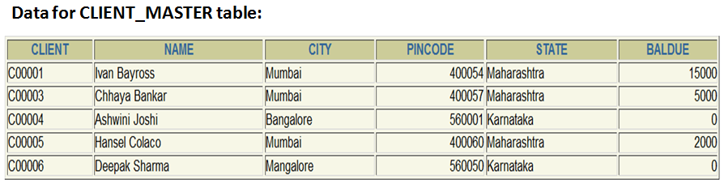

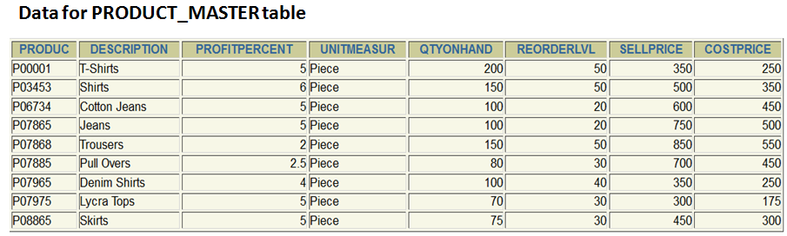

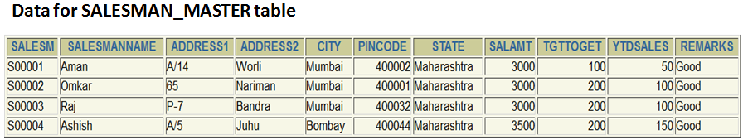
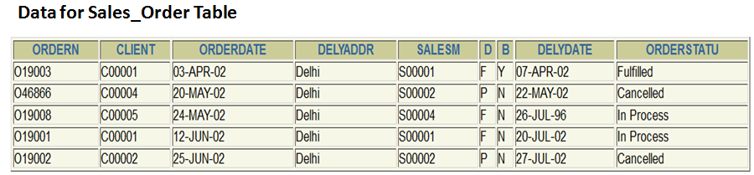

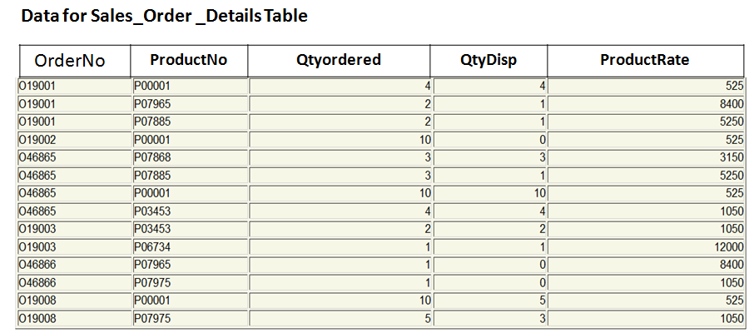

3. Generate the SQL statements to perform the following computations on table data in Python IDLE:
a. List the names of all clients having ‘a’ as the second letter in their names.
b. List the clients who stay in a city whose first letter is ‘M’.
c. List all clients who stay in ‘Bangalore’ or ‘Mangalore’.
d. List all clients whose BalDue is greater than value 10000.
e. List all information from the Sales_order table for order placed in the month of
June.
f. List the Order No & day on which clients placed their order.
g. List the names, city and state of clients who are not in the state of ‘Maharashtra’.

4. Exercises on Using Having, Group By and Joins in Python IDLE:
a. Printing the description and total quantity sold for each product.
b. Calculating the average quantity sold for each client that has a maximum order value of 15000.00.

